1. Write a console application that places double quotation marks around each word in a string .
2. Write an application that receives the following information from a set of students:

Student Id:

Student Name:

Course Name:

Date of Birth:

The application should also display the information of all the students once the data is

Entered. Implement this using an Array of Structures.

1. Write a program to declare a class „staff‟ having data members as name and post. accept this data 5 for 5 staffs and display names of staff who are HOD.
2. Write a program using function overloading to swap two integer numbers and swap two float numbers.
3. Define a class „salary‟ which will contain member variable Basic, TA, DA, HRA. Write a program using Constructor with default values for DA and HRA and calculate the salary of employee.
4. Write a program to implement single inheritance from following figure. Accept and display data for one table.

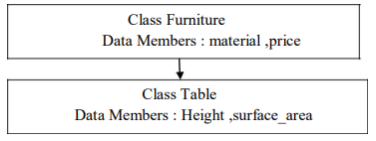

1. Program to implement the following multiple inheritance using interface.

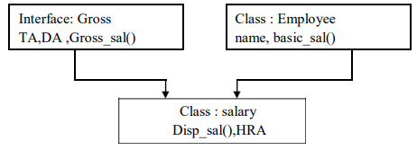

1. Write a program to implement multilevel inheritance from following figure. Accept and display data for one student.

